IFT 166 Introduction to Internet Networking
Lab 2
Connecting at OSI Layers 2, and 3 & Network Configuration

Note: If possible, try to complete this lab where you have multiple computers on the same network

Connecting at OSI Layers 2, and 3

Objectives
- To investigate network connections at OSI Layers 2 and 3
- To determine network addressing information on a Windows 8 PC

Boot into Windows operating on a computer (couldn’t care which one).
You can also attempt this lab on a MAC (might be a little trickier).

OSI Layer 2 (Data Link layer): Investigating MAC addresses

- In the Network and Sharing Center, click on Change adapter settings. Right-click one of the network adapter icons and choose Status, then click Details. Look for the MAC address (called the “Physical address”) in the window that appears. What is the MAC address of this network adapter?

- Right-click the other network adapter icon. What is the MAC address of the other network adapter?

- You can also determine the MAC address from the command prompt. Open the command prompt by typing “cmd” in the metro window.

- At the command prompt, type ipconfig /all. Scroll up and adjust the window size so you can see the information for both of your network adaptors. Locate the MAC addresses (Physical addresses) for the two network adapters. Do these match the ones you determined previously?

OSI Layer 3 (Network Layer): Investigating IP configuration

- In the Network and Sharing Center, click on Change adapter settings. Right-click one of the network adapter icons and choose Status, then click Details.

What is the IPv4 address of this network adapter?
What is the Link-local IPv6 address of this network adapter?
- Right-click the other network adapter icon. What are the IPv4 and IPv6 addresses of the other network adapter?

- You can also determine the IP address from the command prompt. At the command prompt, type ipconfig /all. Adjust the window size so you can see the information for both of your network adapters. Based on the ipconfig /all output, answer the following questions:

- Locate the IPv4 and IPv6 addresses for the two network adapters. Do these match the ones you determined previously?

- In the ipconfig /all output, look for the Autoconfiguration Enabled entry. If it says “Yes”, that means your computer got its IP address from a DHCP server on the network. The IP address of the DHCP server will also be listed. What is the IP address of the DHCP server on this network?

- In order to function fully at OSI layer 3, your computer needs a connection to a router that provides a path to the Internet. This connection is called the Default Gateway. What is the IP address of the Default gateway for this network?

Network TCP/IP Configuration

- Gather basic TCP/IP configuration information
- Open up the command prompt in Windows
- Type ipconfig & press enter (not case sensitive)

Record the following TCP/IP information for your computer

IP Address
Subnet Mask
Default Gateway

- Compare your computer’s TCP/IP configuration to that of others on the LAN
- Are there any similarities?
Yes/No:
- What is similar about the IP addresses?
- What is similar about the default gateway?

- Check additional TCP/IP configuration information via ipconfig /all
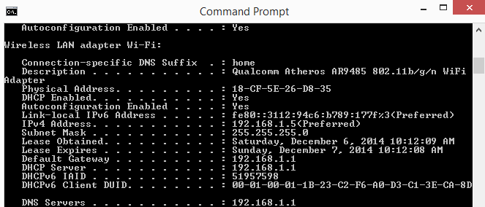

- You should see the following information (computer name, DHCP server’s, if used, and the date the IP lease starts and ends. You might also see entries for DNS servers (used in name resolution)
- You will also see the physical (MAC) address, what is it?

- Write down the IP addresses of any servers listed?
- Write down your computers host name?
- Write down the host names of couple of other computers on the LAN?

